This is a work in progress translation of the Playtronic SNES service manual (manual Técnico). The original manual in Brazilian Portuguese can be found here
Due to a lack of official service documentation for the SNES, I began translating this service manual into English. This proved to be quite the challenge as the original scan is pretty rough, and I do not speak Portuguese. I would estimate the translation is 50% complete, but this has already taken many more hours than I had planned, and I no longer have time to dedicate to completing the translation.
Everything up to page 42 of this document has been reformatted and roughly checked for accuracy against the original manual. But that is not to say everything before page 42 will not contain errors or poor grammar, either due to the original containing those errors, or a mistranslation by myself (or more specifically whatever I used to OCR the original and translate). I did all this a couple of years ago, so I don’t remember exactly what I used.
For the most part all the valuable information has been translated, that includes the service procedure for the console itself, and the burn-in test cartridge fault table (p.21). The remaining stuff that I haven’t touched from page 42 onwards relates to troubleshooting accessories, IC handling and a glossary.
Keep in mind text from the original images has not been translated, and some may be missing due to their poor quality. Basically, if they looked like shit and didn’t offer anything useful, they were not transferred over to this document.
As this manual was written around 1994 it mainly refers to the SHVC revision with only a brief mention of the GPM revision.

If anyone wants to complete the translation, check it for errors, make amendments, add a proper index etc. then please do. Just be sure to make it available somewhere for everyone else.
Good luck,
Mark (TheRetroChannel)
15th May 2026

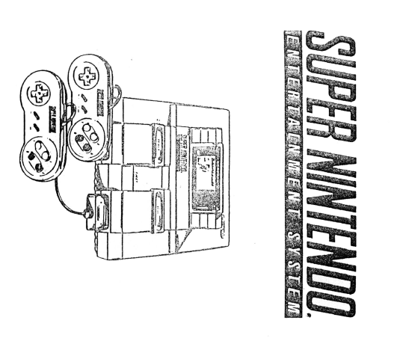

TECHNICAL MANUAL

CONFIDENTIAL
This document contains trade secrets owned by Nintendo/Playtronic and is also protected by the copyright laws of the United States and foreign countries. No part of this document may be reproduced in any form or by any electronic or mechanical means, including information storage and retrieval systems, without permission from any other user.
© 1991 Nintendo
Super NES Technical Manual rev. 01/94

INDEX

OVERVIEW ............................................................................................................. 1-1
SUPER NES CONSOLE OPERATION ........................................................................ 2-1
CONSOLE SUPER NES (GPM) ................................................................................. 3-1
CONTROLLER ........................................................................................................ 4-1
SUPER SCOPE ....................................................................................................... 5-1
MOUSE ................................................................................................................. 6-1
CARTRIDGE ........................................................................................................... 7-1
NOTES ON HANDLING IC's …………………….............................................................. 8-1
GLOSSARY OF TERMS …………………………………………………………………………………… 9-1

OVERVIEW

Console
The Super NES console uses: a Central Processing Unit (CPU), a two-lC Image Processing Unit (PPU1 & 2), and two sound microprocessors.
- CPU - Central Processing Unit

- Specialty built processor by Nintendo
- A 24-bit address bus allowing the CPU to have direct access to 16M of the ROM/RAM at the same time
- 16-bit internal registers
- 8-bit system data bus
- Contains Direct Memory Access (DMA) operations

- PPU1/PPU2 – Picture Processing Unit 1 & 2

- Specialty built processors (two IC’s) by Nintendo
- 128 sprites at most, each with its own priority level, can appear on the screen; 32 sprites in a horizontal line
- The sprites are of one of four sizes: 8 x 8, 16 x 16, 32 x 32 and 64 x 64 pixels
- 32,768 colors available
- Eight color palettes are available, of 16 colors each per canvas, with each sprite consisting of 16 colors of one of the palettes
- Horizontal, vertical and diagonal displacements are possible; Partial vertical displacement is also possible
- Resolution can be 256 x 224, 512 x 224, or 512 x 448 dots
- Special effects functions, including mosaic, windowing, fixed-color addition and subtraction, screen addition and subtraction, and pseudo-512-point horizontal resolution
- 16-bit Data Bus

- Sound microprocessors

- Eight channels of Pulse Code Modulation (PCM) sound
- Stereo digital sound

An AC adapter is supplied with the Super NES that converts 120 volts AC to 10 volts unregulated DC.

Super NES Controller Devices
Controller devices are intended to allow the player to interface with the game (i.e., control actions in the game). There are twelve input function keys on the Controller. The CPU sends control signals to load the function data from the Controller to two 8-bit parallel/serial registers to serial shift registers that output the serial data. This process occurs at software-controlled intervals, approximately every 17 milliseconds.

Super Scope of the Super NES
The Super Scope of the Super NES is a peripheral triggering device composed of two units: a transmitter and a receiver assembly. The Super Scope transmitter detects the timing of the CRT electron beam to determine the location of the sight. This information is then transmitted, through the receiver assembly, to the Console.

Super NES Game Cartridge
Game Cartridges contain memory semiconductor Integrated Circuits (ICs). Current Game Cartridges contain up to two of these memory devices in different combinations of Read-Only Memory (ROM) and Random Access Memory (RAM). The different memories and their functions are listed below.
- Program ROM - Contains the game program and character information. The game program instructs the CPU to send control signals to the microprocessor, check the input of the controller, transfer PPU parameters, calculate the game points and the game time, etc.
- Work RAM - Stores information about game characters and position and provides additional memory space for Console CPU usage. On some Game Cartridges, a low-power Work RAM is connected to a battery in order to maintain information after the Game Cartridge has been removed from the Console.
- 74LS139 - Used as chip selection in the Game Cartridge between the Program ROM, the Work RAM, and the sound processor (when used).
Also included in the Game Cartridges is a Special Integrated Circuit (CIC). The CIC communicates with a corresponding CIC in the Console to prevent unauthorized software from operating in the Console.

SUPER NES CONSOLE OPERATION

Purpose
The Super NES Console contains the system hardware. Its purpose is to display video graphics that are contained in the firmware information programmed and stored in the Read-Only Memory (ROM) and to allow the user interface to play the game. Player control is accomplished by input from reading of the control device made through the Console's CPU. The Super NES can be connected to both a television and a monitor. The multi-output port can provide stereo A/V, RGB, or S-Video (S-VHS) output. An independent output allows RF connection to a television via an RF Switch Set that offers only monaural sound. The Console also has a 28-pin expansion port to allow the connection of external peripheral devices.

Theory of Operation
The Console cannot work on its own. It needs the information programmed and stored in the Read-Only Memory (ROM) on the Game Cartridge and user input from a control device for game play to take place. The main functions of the Console are the execution of instructions stored in the ROM, the production of sound, the development of displays through image processing, the displacement of scenery and the movement of characters as a result of inputs from the controller's device. All this activity takes place under the control of the Central Processing Unit (CPU).

The Console can be subdivided into the eight functional blocks listed below.
1. Power Supply Section 5. RESET IC Section
2. Controller Input Section 6. Sound Section
3. System Timing Section 7. Display Section
4. RESET Section 8. Program Section

Here's a brief overview of the Console Functional blocks.
- Power Supply Section - The AC Adapter provides 10 volts DC unregulated to the Console. The power supply section on the main PCB consists of a noise filter, reverse current protection, power switch, surge suppressor, ripple filter and a voltage regulator. The outputs are 5-volt regulated DC (Vcc) and a 7-volt unregulated DC (Vs) that is used by the sound amplifier.

- Controller Input Section – The Controller Input Section includes diode arrangements and capacitors to protect against voltage spikes, and pull-up resistors to maintain logic levels. The CPU reads input data from the controller approximately every 17ms, but this sampling can be varied at any time by the instructions in the software.

- System Timing Section - System timing encompasses a 21 MHz oscillator, transistors, capacitors, and resistors. The circuit produces a 21 MHz master clock signal to the CPU, to both the PPU IC’s (PPU1 and PPU2), and to the P1 connector. The CPU divides the master clock signal by 6.8 and 12 to produce clock frequencies of 3.58 MHz, 2.68 MHz, and 1.79 MHz respectively. The CPU operates internally at 3.58 MHz. All data transfer for address mapping operates in a standard range of 2.68 MHz. However, depending on the address to be accessed by the CPU, the clock speed can automatically change according to the speed or access time used by the device (RAM, ROM, LSI). Direct Memory Access (DMA) is operated at a clock speed of 2.68 MHz (regardless of address).

- RESET Section - The RESET Section uses a 4 MHz oscillator, a 74HCU04 hex inverter IC, a security IC (CIC), a reset switch, and discrete resistors and capacitors. The CIC of the Console communicates with the CIC of the Game Cartridge. To ensure proper operation of the processors, both PPU ICs should become operational before the CPU. For this reason, the CIC RESET is applied to PPU2 which introduces a delay, before passing the signal to PPU1 and then to CPU.

- RESET IC Section - The RESET IC (voltage detector) ensures that during cut-off of power or low voltage occurrences, the operation of the CPU is maintained to avoid a bad operation or a system leak. This prevents erroneous data from being written to the RAM of the Game Cartridge during memory copying.

- Sound Section - The Sound Section includes a sound module and a sound amplifier. The module contains a sound microprocessor (SMP or 'sound' CPU), Digital Sound Processor (DSP), Digital-to-Analog (D/A) converter, and two 256K RAM ICs. SMP is dedicated to sound processing and has multiple inputs/outputs and monitor programs. The data of program and tone are loaded into RAM from the Game Cartridge Program ROM under the SMP control. The RAM is shared on a time basis by the SMP and DSP. The DSP has eight sound channels Pulse Code Modulated (PCM), noise generator, echo, sweep, envelope and other circuitry to reproduce tone qualities as ordered by the data stored in RAM. The sound amplifier can receive its input from three sources: from the expansion connector (P6), from the 62-pin connector (P1) and the sound module. The amplifier has a left and a right channel, consisting of LM358 operational amplifiers. The op-amp outputs become the stereo output of the multi-output connector (P4). The outputs of the RF modulator and the expansion connector are mixed and become monaural.

- Display Section - The Display Section includes a PPU in two IC’s (PPU1 and PPU2), VRAM (two 256K SRAMs), RGB amplifier circuit, RGB encoder and amplifiers for synchronization and video output. PPU1 and PPU2 function as a single processor to assemble the screen display. However, the main functions of PPU1 are to realize generation, rotation, expansion/reduction of objects and control of scene addresses; while the main functions of the PPU2 are to give color and realize special effect graphics, such as windows, mosaics, increase or decrease color intensity and create RGB image signals from the image data. The image signals are received by the RGB Encoder which creates composite video and S-Video output.

- Program Section - The program section includes the CPU and Work RAM. The CPU is the master controller for Console operations. Some of its functions are listed below:
- Capturing and decoding instructions from the ROM
- Provide timing and control signals for various Console elements and accessories
- Control data transfer between peripheral ICs, including the use of DMA
- Perform arithmetic and logical operations requested by the instructions
- Respond to peripheral control signals generated by ICs, such as RESET

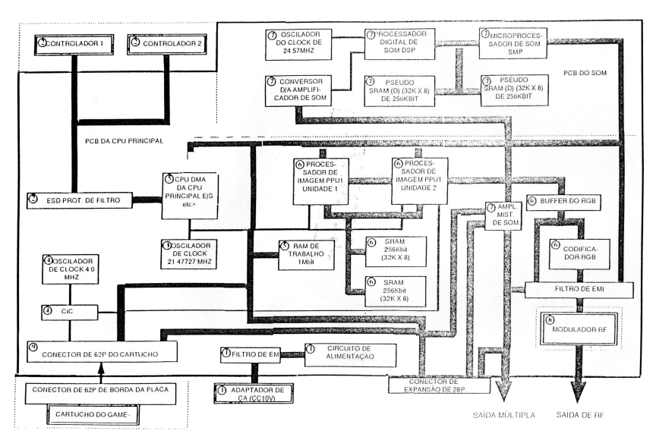

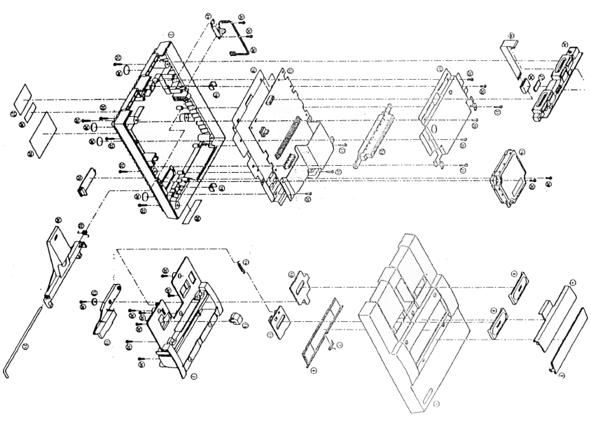
NOTE: The circled numbers correspond to item numbers in the following parts list. (These circled numbers are not part numbers).
ITEM CODE DESCRIPTION QUANTITY
38 340,001.1 Rubber Feet 4
16 640.003.1 Sound Module 1
36 123,001.1 Ferrite Ring 1
17 321.001.1 Upper Shielding 1
18 321.004.1 Lower Shielding 1
23 240.001.1 62-pin Connector Upper 1
1 330.001.1 Upper Shell 1
2 330.005.1 Lower Shell 1
240.012.1 12-pin connector 1
240.013.1 28-pin connector 1
240.018.1 21-pin FFC.S connector 1
153.002.1 Integrated Circuit CPU RF5A22 1
153.005.1 Integrated Circuit PPU1 RF5C77 1
153.006.1 Integrated Circuit PPU2 RF5C78 1
152.004.1 Integrated Circuit WRAM 1M 1
154.001.1 SOP Integrated Circuit BA6592F RGB 1
170.001.1 Axial Fuse 1.5A SSTRr 1
135.002.1 Diode Array DAN202 5
135.003.1 Diode Array DAP202 5
140.001.1 Transistor 2SA1037 6
140.003.1 Transistor 2SC2412 10
140.002.1 Transistor 2SC4699 NP 2
240.003.1 62-pin Connector Lower 1
155.001.1 Integrated Circuit F411 CIC 1
124.001.1 Power Filter ZJYS5012.2PT 1
161.002.1 Ceramic Chip Oscillator 4 MHz 1
160.002.1 Crystal Oscillator 21 MHz
150.001.1 Integrated Circuit 74HCU04 SOP 1
154.002.1 Integrated Circuit LM 358 SOP 1
152.003.1 Integrated Circuit 256K S.RAM 28P SOP 2
ITEM CODE DESCRIPTION QUANTITY
156.001.1 Integrated Circuit 7805 1
320.001.1 Heatsink 1
301.001.1 Insulating Washer 1
300.016.1 Screw 3x10 1
300.017.1 Screw 3x7 5
641.001.1 RF Modulator. SNES 1
240.011.1 Power Jack 1
260.006.1 Reset Button 1
132.003.1 Diode SK. RB110C 1
155.002.1 Integrated Circuit PST529DMT Reset 1
105.002.1 Varistor ERZ. CF2MK220 1
120.002.1 Inductor Chip 22uH NL322522T.22 1
110.003.1 Ceramic Chip Capacitor 0.1 uF/25V 6
110.001.1 Ceramic Chip Capacitor 0.1 uF/50V 15
110.002.1 Ceramic Chip Capacitor 0.047uF/25V 1
110.006.1 Ceramic Chip Capacitor 10pF/50V 4
110.013.1 Ceramic Chip Capacitor 47pF/50V 7
110.014.1 Ceramic Chip Capacitor 56pF/50V 3
110.015.1 Ceramic Chip Capacitor 82pF/50V 4
110.010.1 Ceramic Chip Capacitor 220pF/50V 2
110.011.1 Ceramic Chip Capacitor 300pF/50V 13
110.004.1 Ceramic Chip Capacitor 1000pF/50V 1
110.009.1 Ceramic Chip Capacitor 1 uF/16V 16
112.003.1 Electrolytic Chip Capacitor 10uF/16V 3
112.005.1 Electrolytic Chip Capacitor 33uF/25V 2
112.004.1 Electrolytic Chip Capacitor 2.2uF/25V 1
100.018.1 Resistor Chip 1/10W 39 OHM 3
100.020.1 Resistor Chip 1/10W 56 OHM 1
100.011.1 Resistor Chip 1/10W 100 OHM 13
100.012.1 Resistor Chip 1/10W 120 OHM 3
ITEM CODE DESCRIPTION QUANTITY
100.013.1 Resistor Chip 1/10W 130 OHM 3
100.014.1 Resistor Chip 1/10W 180 OHM 3
100.015.1 Resistor Chip 1/10W 200 OHM 6
100.016.1 Resistor Chip 1/10W 270 OHM 3
100.017.1 Resistor Chip 1/10W 300 OHM 4
100.019.1 Resistor Chip 1/10W 470 OHM 3
100.023.1 Resistor Chip 1/10W 560 OHM 1
100.007.1 Resistor Chip 1/10W 1K OHM 9
100.003.1 Resistor Chip 1/10W 1.2K OHM 2
100.004.1 Resistor Chip 1/10W 1.8K OHM 5
100.009.1 Resistor Chip 1/10W 3.3K OHM 2
100.006.1 Resistor Chip 1/10W 10K OHM 25
100.008.1 Resistor Chip 1/10W 24K OHM 3
100.010.1 Resistor Chip 1/10W 33K OHM 2
100.005.1 Resistor Chip 1/10W 100K OHM 1
300.018.1 Screw M3x8 w/washer 1
30 300.002.1 Screw M3x10 2N AN 17
31 300.001.1 Screw M3x14 4
32 300.003.1 Special Screw N76 6
25 331.001.1 Expansion Connector Cover 1
4 331.003.1 Rear Bottom Panel Case Part 1
5 331.002.1 Rear Top Panel Case Part 1
6 331.033.1 Cartridge Cover - NES 1
7 310.002.1 Cartridge Door Spring 1
8 333.002.1 Power Button 1
9 333.003.1 Reset Button 1
10 322.004.1 Power Button Support 1
11 322.005.1 Reset Button Support 1
19 322.001.1 PCI Support 1
34 240.002.1 Sub. Conj. Connector Module 1
ITEM CODE DESCRIPTION QUANTITY
24 260.001.1 Power Switch 1
20 333.001.1 Eject Button 1
22 310.001.1 Eject Button Spring 1
14 310.003.1 Reset Button Spring 1
21 242.001.1 Eject Button Lock Pin 1
37 341.001.1 Self-adhesive shim 1
39 210.001.1 Wiring Assembly for Power Switch 1
35 201.004.1 Parallel Cable 1
12 336.011.1 SNES Cartridge Lock (IMP) 1
13 334.003.1 SNES Cartridge Lock Holder (IMP) 1
15 333.008.1 Reset button extension 1
3 322.003.1 Chassis 1

CONNECTION

The Super Nintendo Entertainment System can be connected to a TV or VCR. There are several options for connection. If the TV (or VCR) has a left and right AUDIO IN and a VIDEO IN, the Super NES can be connected as shown below.
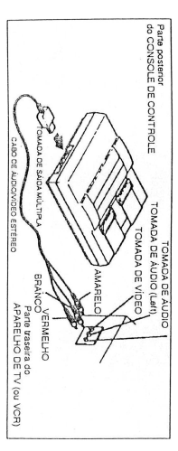
If the TV (or VCR) has an AUDIO IN and a VIDEO IN, a "Y-adapter" should be used. The Y-adapter can be purchased at an electronic parts store.
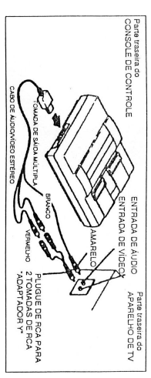
If the TV (or VCR) has a VHF (Type F) cable connector, connect the Super NES as shown below.
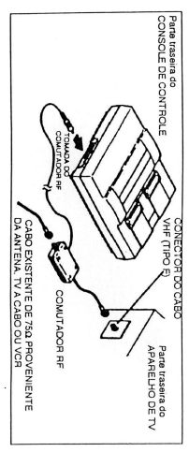
If the (TV or VCR) has a VHF cable connector that uses a 300/75Ω converter, connect the Super NES as shown below.
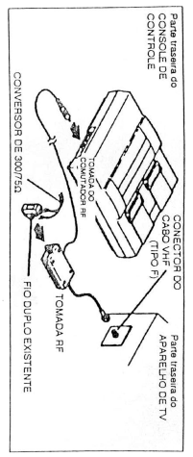
If the TV uses an F-type VHF connector and a 75/300Ω cable, use the connection method shown below.
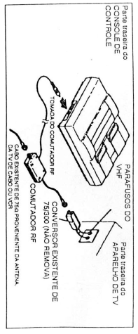
If the TV uses a screw-type VHF connector and dual wires, the 75/300Ω converter and a 300/75Ω converter will need to be connected as shown below.
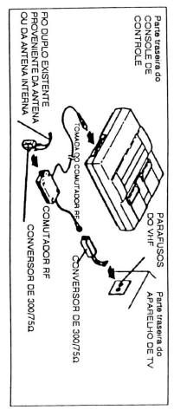

If a TV, VCR or Stereo receiver accepts the S-Video input, an S-Video cable (part no. 22425) can be used to connect the Super NES as shown below. (NOTE: The S-Video cable is not included with the Super NES).
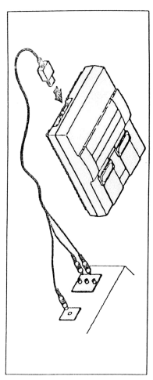
The Super NES can be connected along with the NES to a TV, monitor or VCR as shown below.
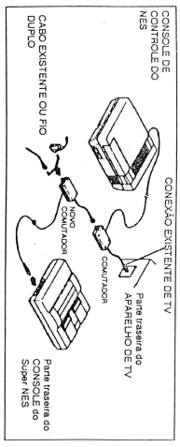
NOTE: In some cases, this connection may cause attenuation of channels higher than 13.

GENERAL INSTRUCTIONS FOR DISASSEMBLING THE SUPER NES CONSOLE

Disassembling the Console
- Removal of the Upper Cabinet; Before dismantling: Turn on the power supply of the Console with the AC Adapter unplugged to discharge the capacitor C67 (This capacitor can discharge during maintenance, causing damage to components). Place the unit upside down so that the bottom of the case is facing up. Use the larger tip of the GameBit screwdriver, remove the six (6) security screws of the case. Turn the unit over and remove the top case.

- Removing the Sound Module: Remove the two (2) screws on the opposite sides of the sound module. To remove, lift the module vertically.

- Cartridge Mechanism: Lift the ejector bar supporting the mechanism, and then pull it out to the right. Lift the ejector mechanism out of the unit.

NOTE: Observe the position of the ejector spring to reassemble it correctly.

- Power Switch: Remove the two (2) screws from the power switch. Disconnect the power switch cable from the output of 2-pin terminals and remove the power switch assembly.

- Removing the Controller Port PCB: The PCB from the controller port is connected to the main PCB by an 11-way ribbon cable. Pull the cable lightly from the connector and remove the lower chassis controller port PCB.

- Removing the Upper Shield: Remove the six (6) screws from the upper shield and remove the upper shield from the Console. Most of the PCB should be visible at this point. Remove the remaining three (3) screws on the back of the unit.

NOTE: When remounting, the chrome screws are longer and positioned on each side of the 62-pin connector, and in the vicinity of the output ports (RF and Multi), on the back of the unit.

- 62-Pin Connector: Grab the top of the 62-pin connector and pull it firmly to remove it. Lift the PCB out of the bottom enclosure.

Disassembly of the Upper Cabinet
- Put the upper cabinet upside down and remove the reset spring using needle nose pliers.

- Remove the 7 (seven) screws that appear.

NOTE: Observe the location of the support washer on the cartridge plate lock to reassemble it correctly.

- Lift the cartridge lock plate vertically, then toward you. Remove the cartridge plate lock.

- Remove the final screw and lift the cartridge socket out of the top case.

- Hold the upper case and push the case cover upwards, grasping the bottom using your other hand, pull the case cover toward you to remove it

NOTE: Observe the position of the spring of the case cover to reassemble it correctly.

- Place the upper case upside down taking care the power and reset switches are in the OFF position. Remove the logo panel by vertically lifting the piece.

- Remove the power and reset switches by turning over the upper case, compressing the four purple-colored tabs and pushing down.

TEST PROCEDURE FOR THE CONSOLE

Equipment Required:
- Stereo Television/Monitor
- Super NES AC adapter
- (S)NES RF Switch
- Super NES Stereo A/V Cables
- Two (2) Super NES Controllers
- Super Mario World Game Cartridge
- Super NES Burn-In Cartridge

Test Procedure:
Before inserting the game cartridge into the console, check the upper 62-pin connector for damage or contamination.
- Plug the AC adapter, RF Switch, Stereo A/V Cables into the console.

- Plug the controllers into the plug of each port (no.1 and no.2) and insert the game cartridge Super Mario World into the console.

- Apply power to the console and adjust the TV's display mode to RF. Select the appropriate channel (3 or 4) for clear operation.

- Using the no.1 Controller, select the two-player function and start the game.

- Play the game for a short time and observe if the operation is adequate (color, image and sound). It’s good to scroll the screen 3 or 4 times. Test both controllers for complete and accurate operation.

- Turn the channel selectors of the TV and RF modulator to test the sound, color and image of the game on both channels 3 and 4. Tinker with the RF connector while connected to ensure that the connection is solid. Switch the TV mode from RF to A/V and tinker on the multiple-output plug in a similar manner. While in A/V mode, test the stereo output.

NOTE: Before performing any repairs to the PCB, test the unit again using a known good sound module and upper 62-pin connector.

TROUBLESHOOTING

SNS Console Test Device
1. Burn-In Test
The Burn-In Test tests the system RAM and registers, verifying the Read/Write functions from the CPU, and verifying the accuracy of the returned values.

Priority for Replacement of Defective Components
Test | 1 | 2 | 3 | 4
WRAM | CPU | WRAM
DRAM | CPU | WRAM
VRAM (LOW) | PPU1 | CPU | SRAM (U5) | PPU2
VRAM (HIGH) | PPU1 | CPU | SRAM (U4) | PPU2
DMA MEMORY | CPU
OAM | PPU1 | CPU
CG | PPU2 | CPU
MPY 8X8 | CPU
MPY 16X8 | PPU1 | CPU
DIV 16/8 | CPU
DMA | CPU | PPU1 | PPU2
EXT LATCH | PPU1 | CPU
HV TIMER | CPU | PPU2 | PPU1
VRAM COUNT | PPU1 | CPU
V224/V239 | CPU | PPU2 | PPU1
FIELD FLAG | PPU2 | CPU | PPU1
VH FLAG | PPU2 | CPU | PPU1
OBJ L OVER | PPU1 | CPU
CPU (CLOCK) | CPU
CPU | CPU
APU | SOUND MODULE | CPU

If multiple errors occur, judge after having considered all the factors. Remember that the CPU checks the functions of each LSI through the bus lines.

2. Controller Port Signals
Defective Item | Test Location | Location to Verify
RAMSEL | Test RAMSEL signal from P1 | P1 no 32
REFRESH | Test P1 REFRESH signal | P1 no 33
OUT0 | Test OUT0 signal from the output port | P2, R91, DA1, DA6, C43, CPU
4016D0, 4016D1 | Test Gateway Port 4016 | P2, R87, R88, DA3, DA8, C39, C40, CPU
4017D0, 4017D1 | Test Gateway Port 4017 | P2, R85, R86, DA4, DA9, C37, C38, CPU proximity
PP6, PP7 | Test Gateway E/S PP6, PP7 | P2, R83, R84, DA, C35, C36, CPU proximity
62P PA, 62P CA | Test Address Line P1 | P1
Through | Test the through line  1 (throught) from P1 to P6 | P1 no2, P6 no24, R97
IRQ | Test the external signal of  interrupt for CPU | P1 no18, P6 no26, R29, CPU

3. 4 MHz Oscillation Frequency Measurement
(Acceptable Range: 3.8 to 4.2 MHz)
When the 4 MHz oscillation frequency relative to the CIC clock measured is outside the acceptable range, verify:
The 4MHz Ceramic Oscillator (X2)
HCU04 (U9)
Other peripheral circuits
The CIC will not function properly if the clock does not oscillate. However, the output of the reset signal (pin 10) may still become High (auto) (regardless of clock operation). In this case, the CPU and PPU will operate normally.

Color Tone Defects
Color tone problems are mainly caused by a faulty circuit after PPU2. The defective component(s) may be identified depending on the output that is affected (Composite Video, RGB, S-Video, or RF output).
1. Monochrome screen
Check Oscillation Frequency of 21.453666 MHz (PAL-M), 21.477272 MHz (NTSC), or 21.281370 MHz (PAL)
If adjustment is impossible or unstable, replace in sequence:
Compensator Capacitor (TC1)
21 MHz Oscillator (X1)
Check Image Output (RF, Composite Video)
If only the RF output is defective, replace the RF modulator.
If both outputs are defective, check the discrete components around the RGB Encoder (U7) for soldering defects and damage. Replace in sequence:
RGB Encoder (U7)
PPU2 (U3)
2. Defective Screen Color (reddish, bluish, etc.)
RGB and S-Video are defective
Probable causes are: A faulty PPU2, missing/interrupted signals RED, GREEN, OR BLUE coming from the RGB output. Check around the transistors (Q3 to Q9) that amplify the RGB signal, to see if there are any soldering defects or damage. Change the PPU2 (U3).
Only the RGB image is normal
Probable causes are a faulty RGB encoder or faulty color signal filters (C14, C16). Check the discrete components around the RGB Encoder (U7) for soldering defects or damage. Replace RGB Encoder (U7)

Image Defects
The same problems can appear due to dashes or lines on the input or output side. This should be taken into account if the problem is not remedied by changing the component.

1. Vertical lines
If the characters are normal and vertical lines appear in the characters.
Swap in sequence: PPU2 — > PPU1 — > CPU — > VRAM

If the characters are faulty and vertical lines appear.
Swap in sequence: PPU1 — > PPU2 — > CPU — > VRAM

2. Mosaic screen/Defective characters
Swap in sequence: PPU1 — > PPU2 — > CPU — > VRAM

3. Defective Character/Color Priority of Object
Swap in sequence: PPU1 — > PPU2 — > CPU

4. Screen Jitter/Part of Screen is not Displayed
Swap in sequence: PPU1 — > PPU2 — > CPU — > VRAM

5. Window Screen Position Shifts
Swap in sequence: CPU — > PPU2 — > PPU1

6. Defective image when using a Specific Game Cartridge
Swap in sequence: CPU — > PPU2 — > PPU1

CONSOLE DIAGNOSTICS TABLE

Before performing any repairs to the console, disassemble the unit and inspect the PCB entirely. Look for damaged/missing components or traces, soldering defects, and dirt or corrosion. Do not attempt to clean the 62-pin connectors: they will need to be replaced.
MALFUNCTION | PROBABLE CAUSE (in order of priority)
Solid Color Screen | Faulty 62 Pin Connector  Faulty Sound Module  Poor soldering  U1 (CPU) Faulty  U3 (PPU2) Faulty  U6 (WRAM) Faulty  U2 (PPU1) Faulty  U7 (RGB Encoder) Faulty  X1 (21 MHz Oscillator) Faulty  U8 (CIC) Faulty
Distorted Video | Faulty 62-pin connector  Poor soldering  U3 (PPU2) Faulty  U1 (CPU) Faulty  U2 (PPU1) Faulty  U4 or U5 (256K RAMs) Faulty
Distorted or Missing Sound | Sound Module Faulty  P5 Connector Faulty  U1 (CPU) Faulty  U10 (Amp) Faulty  Q18 Faulty
No RESET | U8 (CIC) Faulty  X2 (4 MHz Oscillator) Faulty  U9 (74HCU04) Faulty
Weak or Missing Color | Defective TC1 - The master clock frequency should be set at 21.453666 MHz (PAL-M), 21.477272 MHz (NTSC), or 21.281370 MHz (PAL)  U3 (PPU2) Faulty  U7 (RGB Encoder) Faulty  X1 (21 MHz Oscillator) Faulty
No Power | F1 (1.5A Fuse) Faulty  D1 Faulty  T1 (Line Filter) Faulty  U12 (7805 Regulator) Faulty  VA1 (Peak Absorber) Faulty  Q18 Faulty  P3 (Power Switch) Faulty
MALFUNCTION | PROBABLE CAUSE (in order of priority)
Screen Interference | RF Modulator Faulty
Intermittent or Missing Controller Operation | Front Unit PCB Assembly Faulty  FCC Harness Faulty  P2 Connector Faulty  U1 (CPU) Faulty
Frozen screen/erratic program operation | 62-pin Connector Faulty  Poor soldering  U1 (CPU) Faulty  U3 (PPU2) Faulty  U2 (PPU1) Faulty

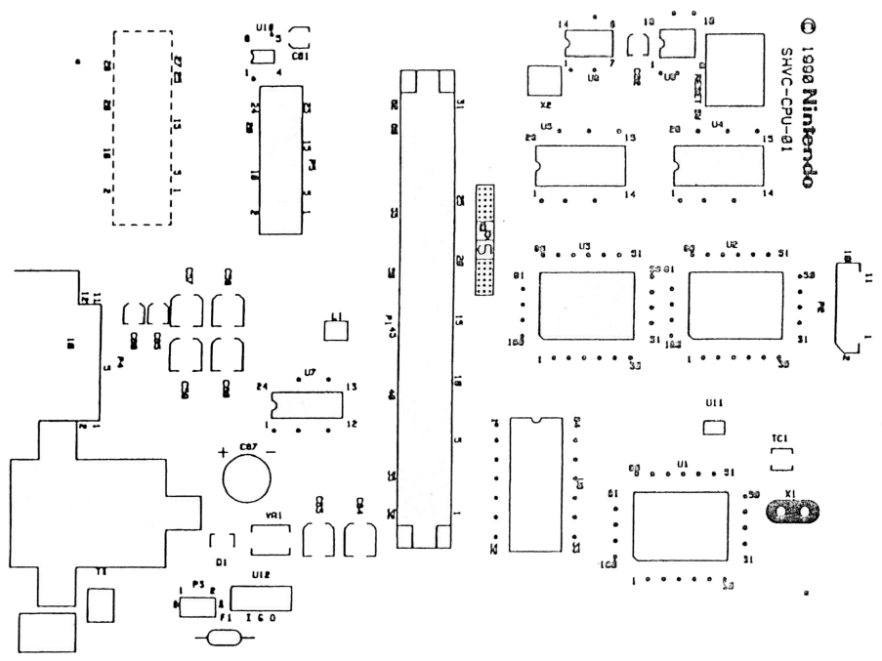

SHVC-CPU-01
COMPONENT LAYOUT (TOP SIDE)
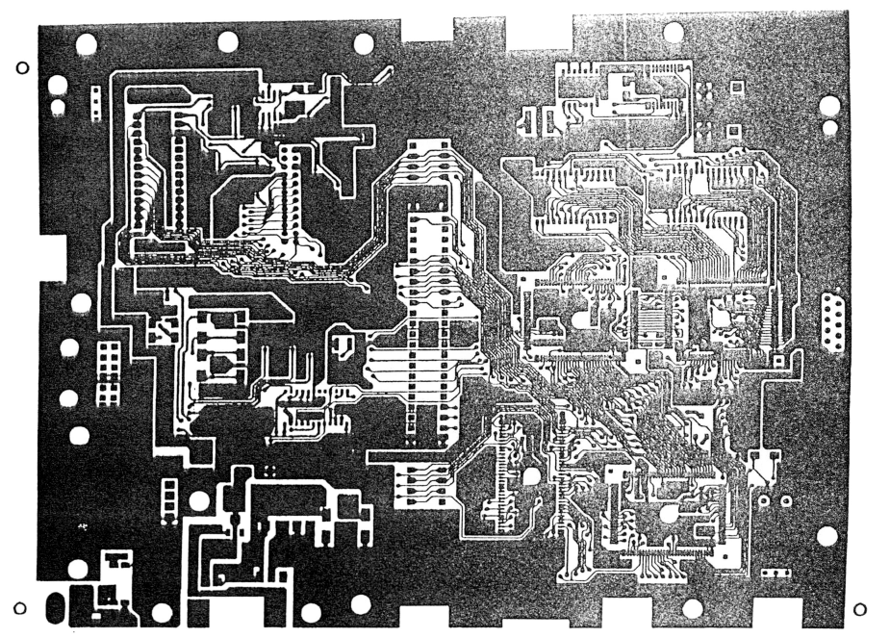
SHVC-CPU-01
TRACK LAYOUT (TOP SIDE)

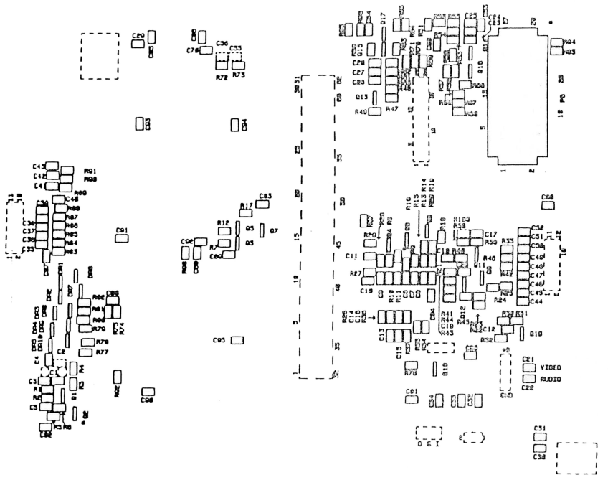
SHVC-CPU-01
COMPONENT LAYOUT (UNDER SIDE)

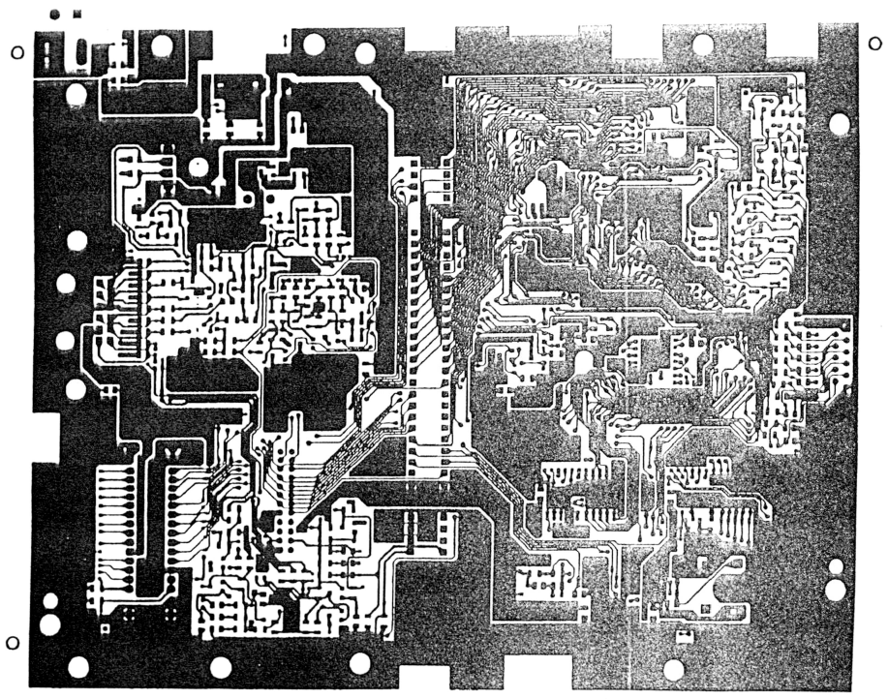
SHVC-CPU-01
TRACK LAYOUT (UNDER SIDE)

CONSOLE SUPER NES (GPM)

Purpose
The Super NES CPU PCB is now being manufactured with the application of the latest technological novelty: Basic Plane Method (GPM). This process uses a base layer between the track layout and the solder mask on the PCB, thus eliminating the need for the bottom RF shielding. In addition to the new GPM technology, other modifications have been made to the Super NES CPU PCB: the PCB is shorter in length, the C67 capacitor and 4 MHz Oscillator have been removed, the sound module circuitry has been manufactured directly on the board, the TC1 is now a through-hole mounted component, and the number of discrete components has been modified/added or removed. To accommodate the new PCB size, the bottom enclosure and upper RF shield have been modified. In addition, the lock bar (to prevent insertion/removal of the game cartridge with the console's power on) has been removed from the top case, and a warning label has been added.

Theory of Operation
The main functions of the Console are the execution of instructions stored in the game cartridge, the production of sound, the display of images through the processing of figures, the movement of scenarios and the movement of characters as a result of inputs from the controller's device. All of this activity takes place under the control of the Central Processing Unit (CPU).

The Console can be subdivided into the seven functional blocks listed below.
1. Power Supply Section 5. Sound Section
2. Controller Input Section 6. Display Section
3. System Timing Section 7. Program Section
4. RESET section

The theory of operation for each of these functional blocks is the same as in the Original Console with the exception of the System Timing and Reset Section. Information regarding these sections will be included in a future update.
NOTE: The Block Diagram, Connection, Test Procedure, Scheduled Troubleshooting, and Diagnostic Table are generally the same and should be used.

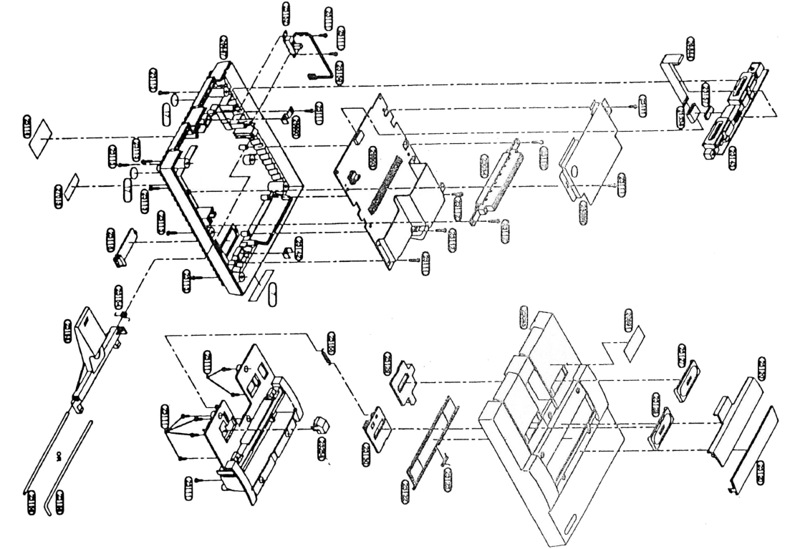

ITEM CODE DESCRIPTION QUANTITY
17 340,001.1 Rubber Feet 2
21338 123.001.1 Ferrite Ring 1
23084 240.001.1 62-pin Connector Upper 1
23085 330.001.1 Upper Case 1
23111 300.002.1 Screw M3x10 2N AN 16
23112 300.001.1 Screw M3x14 4
23113 300.003.1 Special Screw N76 6
23118 331.001.1 Expansion Connector Cover 1
23120 331.003.1 Rear Bottom Panel Chassis Part 1
23121 331.002.1 Rear Top Panel Chassis Part 1
23122 331.033.1 Cartridge Cover - NES 1
23123 310.002.1 Cartridge Door Spring 1
23127 333.002.1 Power Button 1
23128 333.003.1 Reset Button 1
23129 322.004.1 Power Button Support 1
23130 322.005.1 Reset Button Support 1
23142 322.001.1 PCI Support 1
23143 240.002.1 Sub. Conj. Connector Module 1
23152 260.001.1 Power Switch 1
23153 333.001.1 Eject Button 1
23154 310.001.1 Eject Button Spring 1
23155 310.003.1 Reset Spring 1
23156 242.001.1 Eject Button Lock Pin 1
23157 341.001.1 Self-adhesive shim 1
23159 210.001.1 Wiring Assembly for Power Switch 1
23258 333.008.1 Reset Button Trigger Extension 1
23259 322.003.1 Chassis 1
26887 330.002.1 Lower Case 1
26888 201.001.1 Parallel Cable (GPM) 1
26889 321.001.1 Upper Metal Shielding (GPM) 1
ITEM CODE DESCRIPTION QUANTITY
26890 322.002.1 PCI Support (GPM) 1
240.012.1 12-pin connector 1
240.013.1 28-pin connector 1
153.002.1 Integrated Circuit CPU RF5A22 1
153.005.1 Integrated Circuit PPU1 RF5C77 1
153.006.1 Integrated Circuit PPU2 RF5C78 1
152.004.1 Integrated Circuit 1M WRAM 1
154.001.1 Integrated Circuit BA6592F RGB SOP 1
170.001.1 Fuse 1.5A SSTR Axial 1
135.002.1 Diode Array DAN202 5
135.003.1 Diode Array DAP202 5
140.001.1 Transistor 2SA1037 6
140.002.1 Transistor 2SC2412 10
140.002.1 Transistor 2SC4699 NP 1
240.003.1 62-pin Connector Lower 1
155.001.1 Integrated Circuit CIC F411 1
124.001.1 Line Filter ZJYS5012-2PT 1
150.001.1 Integrated Circuit 74HCU04 SOP 1
152.003.1 Integrated Circuit 256K S-RAM 28P SOP 1
156.001.1 Integrated Circuit 7805 1
320.001.1 Heatsink 1
301.001.1 Insulating Washer 1
300.016.1 Screw 3x10 1
300.017.1 Screw 3x7 4
641.001.1 RF Modulator - SNES 1
240.011.1 Power Jack 1
260.006.1 Reset Switch 1
132.003.1 Diode SK-RB110C 1
155.002.1 Integrated Circuit Reset PST529DMT 1
120.002.1 Inductor Chip 22uH NL322522T-22 1
ITEM CODE DESCRIPTION QUANTITY
110.003.1 Ceramic Chip Capacitor 0.1 uF/25V 25
110.001.1 Ceramic Chip Capacitor 0.01 uF/50V 3
110.002.1 Ceramic Chip Capacitor 0.047uF/25V 1
110.006.1 Ceramic Chip Capacitor 10pF/50V 4
110.013.1 Ceramic Chip Capacitor 47pF/50V 7
110.014.1 Ceramic Chip Capacitor 56pF/50V 1
110.015.1 Ceramic Chip Capacitor 82pF/50V 4
110.010.1 Ceramic Chip Capacitor 220pF/50V 4
110.011.1 Ceramic Chip Capacitor 300pF/50V 13
110.004.1 Ceramic Chip Capacitor 1000pF/50V 3
110.009.1 Ceramic Chip Capacitor 1 uF/16V 16
112.003.1 Ceramic Chip Capacitor 10uF/16V 3
112.005.1 Ceramic Chip Capacitor 33uF/25V 2
112.004.1 Ceramic Chip Capacitor 2.2uF/25V 1
100.018.1 Resistor Chip 1/10W 39 OHM 4
100.020.1 Resistor Chip 1/10W 56 OHM 1
100.011.1 Resistor Chip 1/10W 100 OHM 13
100.012.1 Resistor Chip 1/10W 120 OHM 3
100.013.1 Resistor Chip 1/10W 130 OHM 3
100.014.1 Resistor Chip 1/10W 180 OHM 3
100.015.1 Resistor Chip 1/10W 200 OHM 5
100.016.1 Resistor Chip 1/10W 270 OHM 3
100.017.1 Resistor Chip 1/10W 300 OHM 4
100.019.1 Resistor Chip 1 /10W 470 OHM 3
100.007.1 Resistor Chip 1/10W 1K OHM 10
100.003.1 Resistor Chip 1/10W 1.2K OHM 2
100.004.1 Resistor Chip 1/10W 1.8K OHM 6
100.009.1 Resistor Chip 1/10W 3.3K OHM 2
100.006.1 Resistor Chip 1 /10W 10K OHM 25
100.008.1 Resistor Chip 1/10W 24K OHM 3
ITEM CODE DESCRIPTION QUANTITY
100.010.1 Resistor Chip 1/10W 33K OHM 2
100.005.1 Resistor Chip 1/10W 100K OHM 2
240.017.1 11-Pin FCC-A Connector 1
300.018.1 Screw M3x8 w/washer 1
161.001.1 Ceramic Oscillator 24 MHZ 1
154.003.1 Integrated Circuit LM324 SOP 1
153.004.1 Integrated Circuit CXP 1100Q S-SMP 1
153.003.1 Integrated Circuit CXD 1222Q S-DSP 1
153.007.1 Integrated Circuit UPD6376 1
330.018.1 Crystal Oscillator 21 MHZ 1
152.002.1 Integrated Circuit 256K PSEUDO RAM SOP2
105.001.1 Varistor ERZ-C05DK220 1
113.001.1 Capacitor Trimmer 20pF 1

CONTROLLER

Purpose
The Super NES Controller is intended to provide a player interface with the Console to control the action in the game being made. It features a cross-style directional control pad that allows for movement in eight directions (up, down, left, right, and combinations thereof), buttons for game selection/start, and six buttons for game-dependent features

Theory of Operation

1. Single IC – The Single IC Controller uses a 14-bit parallel/serial input 56V520 (IC-A) for the serial output shift register. Twelve of the parallel inputs are connected to earth via open carbon contact surfaces on the Controller PCB. When a driver is squeezed, a contact pad is pressed against the carbon surface, causing the corresponding PI input line to be connected to the ground. The Controller has four inputs from the Console and one output to the Console. The inputs are: VDD, VSS, Clock and P/S (OUTO). A serial output is provided to the Console starting with Q14 (pin 9) IC-A. The console sends an OUTD pulse to load information into the shift logger. This information is then synchronized by successive clock pulses (CLK) from the Console.

2. Dual IC - The Dual IC Controller utilizes two 56W545 8-bit offset registers (IC-A and IC-B) of parallel/serial input for serial output. Twelve parallel inputs are connected to the ground via open carbon contact surfaces on the Controller PCB. When a trigger is tightened, a contact pad is pressed against the carbon surface causing the corresponding PI input line to be connected to the ground. The controller has four inputs from the Control Console and one output to it. The inputs are: VDD, VSS, Clock and P/S (OUTO). Q8 is the output to the Control Console from IC-A. The CPU carries data from the Controller into each displacement register, sending the OUTO pulse.
The Controller data is then serially synchronized. The data consists of twelve bits, one for each function of the Controller. The first 8 functions of the Controller are sent from the IC-A, while the remaining four are sent from the IC-B to the serial input of IC-A and then to the Console.

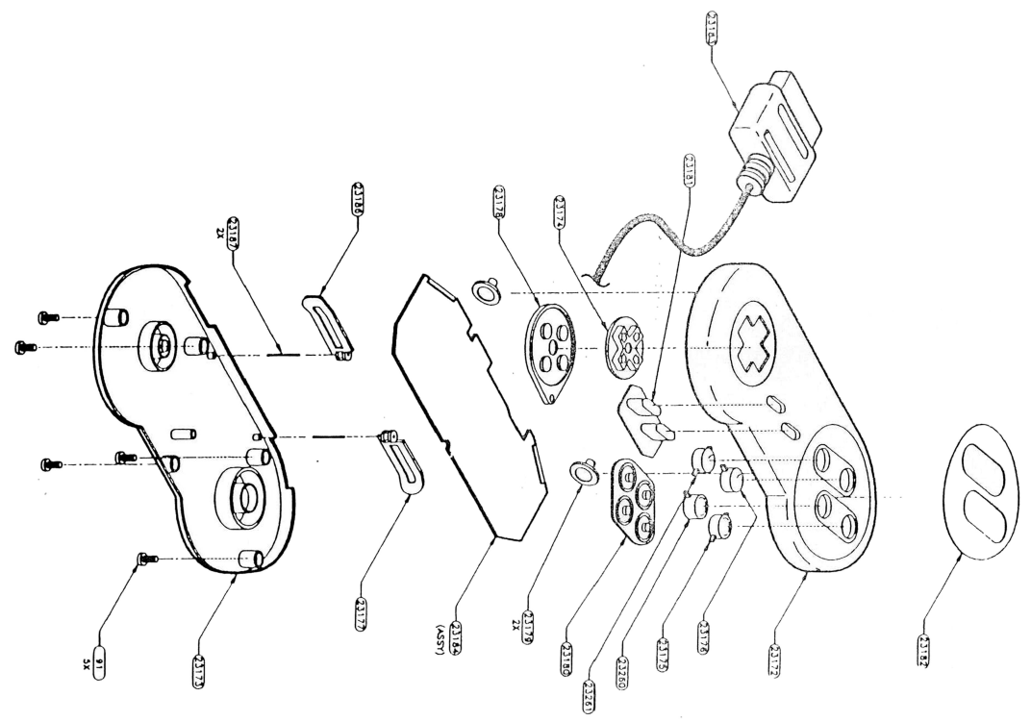

ITEM CODE DESCRIPTION QUANTITY
91 300.019.1 Parafuso M2x8 5
23172 330.003.1 Upper Control Cabinet 1
23173 330.004.1 Lower Control Cabinet 1
23175 333.012.1 Button A 1
23176 333.010.1 Button X 1
23177 333.014.1 R Button 1
23178 342.001.1 Directional Contact Blanket 1
23179 342.004.1 Contact blanket Buttons R/L 2
23180 342.002.1 Button Contact Blanket A.B.X.Y 1
23181 342.003.1 Manta Select/Start 1
23182 540.134.1 Button Adhesive A,B,X,Y 1
23183 201.003.1 Controller Cable with 7-Pin Plug 1
23184 230.015.1 PCI Control Mounted 1
23186 333.015.1 L Button 1
23187 322.008.1 R/L Buttons Pin 2
23260 333.013.1 Button B 1
23261 333.011.1 Button Y 1

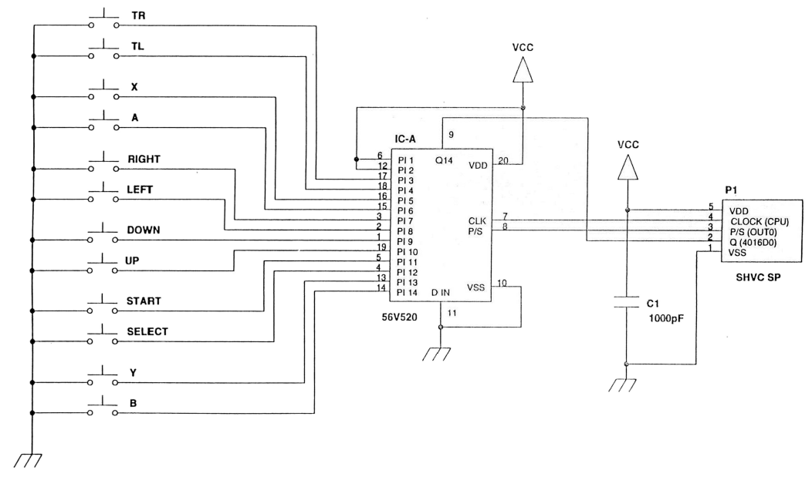

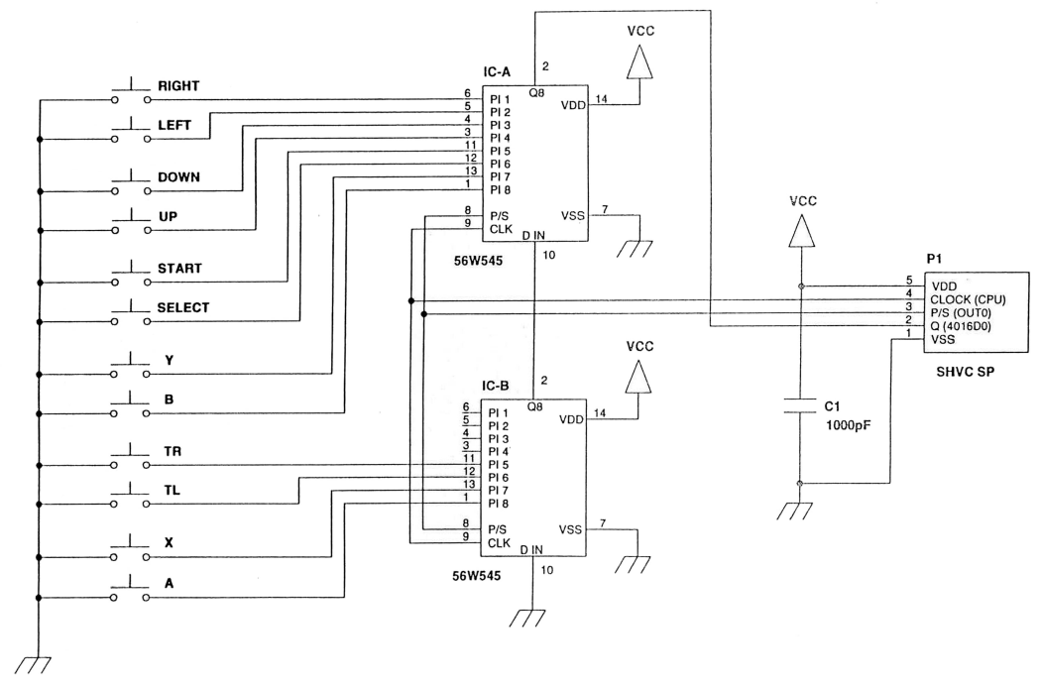

CONTROLLER TEST PROCEDURE

Equipment Required:
1. Television Monitor
2. Console do Super NES
3. Super NES AC Pack
4.Super NES Stereo A/V Cables or SNES RF Assembly Super NES Test Cartridge

Procedure:
- Connect the Console to the television monitor.

- Plug the Controller to be tested, insert the Test Cartridge and turn on the Console.

- Select and start the test portion of the Controller from the menu screen. Tighten all triggers in sequence, following the arrow indicator. As each trigger is pressed, the corresponding area on the display screen will change to red (while the trigger is tightened), and then to blue.

NOTE: IF WITHIN 10 SECONDS NO CONTROLLER ACTIVITY IS DETECTED, A FAULT CONDITION WILL BE DISPLAYED.

- Look for any signs of defect. This covers but is not limited to: slow response, triggers that indicate on the screen that you are being squeezed, when you are not really pressing them, and triggers that do not change color on the screen when you are pressing them.

- Turn off the Control Console and remove the Controller. If no problems appear operating with the Controller, go to step 6. Refer to the diagnostic table of the Controller to determine the most likely cause of a defect condition.

- Disassemble the Controller and inspect the contacts for excessive wear, inspect the cable and the enclosure for cosmetic damage.

- Reassemble the Controller and test it again.

T A B E L A DE D IAG N Ó STIC O S DO C O N TR O LLER
Before performing any repairs to the Controller, disassemble and inspect the enclosures, cable, contact pads, PCB, drivers, and internal wiring for physical damage and/or excessive soiling. Do not attempt to repair or clean the contacts: they must be replaced.
PROBABLE CAUSE MALFUNCTION (in order of priority)
Slow response Contacts spent
Dirty/damaged PCB contacts surface
All functions operate faulty CI-A/CI-B
Simultaneously Faulty PCB Faulty Cable
Random or missing reply Contacts spent
Faulty CI-A/CI-B Faulty cable Faulty PCB
SUPER SCOPE
Purpose
The Super Scope of the Super NES is a peripheral game triggering device that provides the game player with a wireless interface to the console. In Super Scope games, the player tries to hit targets that are placed on the screen.
THEORY OF THE PERATION
1. Super Scope Transm issor - Power supply by six AA batteries to the Super Scope. This input voltage is regulated to 5 volts DC. There are four key triggers in Super Scope: trigger, pause, cursor, and power switch that determines whether the trigger function will operate as single or turbo fire (software dependent). The light receiver (GAMP) detects and counts the tracking scans coming from the CRT. This information is amplified and sent to the Super Scope's CPU to see if there is noise detection, or to a tracking port for the output carried out by the infrared transmitter.
The Super Scope's CPU is used to process the key inputs, generate the corresponding code, and control the tracking port. The tracking port is used by the CPU to control the tracking signals sent to the Super NES. The infrared transmitter combines the CPU code and tracking signals to be sent to the Super Scope Receiver. The Super Scope utilizes the external latch function of the Super NES's horizontal/vertical counter (tracking counter). The outer latch maintains the X and Y coordinates of the electron beam (or tracer scan line) when the Super Scope is triggered to send out tracking pulses that detect from the Cathode Ray Tube (CRT). The X and Y coordinates detected during the aiming portion of game preparation are used as deviation values during gameplay.
The distance from the Super Scope to the CRT can restrict operation, presenting an insensitive area at the base and on an edge of the screen. Eyepiece deflection in the Super Scope creates an optical angle between your visual vision and the optical axis of the Super Scope. The optimal distance for operation is 3 meters (about 10 feet).
2. Super Scope Receiver - The Super Scope Receiver draws power from the Super NES Console
and operates using port n2 2. The Receiver consists of an infrared receiver/amplifier, a
CPU, on a shift register, and on a tracking port. The receiver/amplifier
Infrared makes the tracking signal pass through the tracking port, under the control of the
Receiver CPU and reconverts the infrared signal received from the Super Scope to code pulses
to the CPU. The receiver's CPU decodes the pulses received from the infrared receiver amplifier
and sends the key inputs to a shift register for the output to the Control Console
of the Super NES. The shift register temporarily stores the key entry code
from the receiver's CPU until it is accessed by the Super NES's CPU. The tracking port
is used by the receiver's CPU to control the timing of the trace signals sent
for the entrance of the external latch.
From: Super Scope
Super NES
Y — 24421
24425
Super NES SuperScope Technical Manual
ITEM CODE DESCRIPTION QUANTITY
24420 630.001.1 Sight Mounted Assembly 1
121 300.006.1 M3x10 PHP Steel Threaded Screw 13
24269 335.001.1 Sight Tube 1
24270 332.001.1 Visor da Mira 1
24421 331.012.1 Right Side of Sight 1
24422 331.013.1 Left Side of Sight 1
24423 331.021.1 Mira Frontal 1
23111 300.002.1 Parafuso M3x10 2N AN 4
24425 331.014.1 Right Side 1
24426 331.015.1 Left main back 1
24427 331.016.1 Secondary right side 1
24428 331.017.1 Left Secondary Side 1
24429 339.001.1 Plastic line 1
24430 332.003.1 LED Display 1
24431 332.002.1 Lens 1
24432 331.022.1 Lens Protector 1
24433 333.007.1 Push button 1
24434 300.009.1 M2x10LH Steel Threaded Bolt 2
24435 220.001.1 Battery Contact 1
24436 540.007.1 Product Name Label 2
24440 339.002.1 Right stock 1
24441 339.003.1 Left stock 1
24443 331.023.1 Key holder 1
24444 333.004.1 Power Button 1
24445 335.005.1 Shutter button 1
24446 336.006.1 Pause Button 1
24448 202.001.1 Cabo tipo flat 4C-340L 1
ITEM CODE DESCRIPTION QUANTITY
24449 202.002.1 Cabo tipo flat 4C-90L 1
24450 230.014.1 PCI Mounted Amplifier 1
24451 230.026.1 PCI CPU Mounted, Cursor 1
24452 260.004.1 Chave Power 1
24453 260.011.1 Chave Pause/Cursor 1
24454 260.003.1 Trip switch 1
24456 230.017.1 PCI Montado leds 1
24458 331.007.1 Battery Cover 1

152 340.002.1 Bores 4
23111 300.002.1 Parafuso M3x10 2N AN 4
24467 210.002.1 Conj. Entrance Socket with 7 Pins 1 Plug 1
24459 331.024.1 Tampa to Receptor 1
24460 331.019.1 Base do receptor 1
24461 332.004.1 Visor to receptor 1
24462 540.037.1 Receiver Label 1
24464 230.027.1 PCI Montado receptor 1

TEST PROCEDURE FOR SUPER SCOPE
Equipment then Needed:
1. Television Monitor
Console do Super NES
Controller do Super NES
Super NES AC adapter
Super NES Stereo A/V Cables or SNES RF Assembly Super NES Test Cartridge
Six AA Batteries
Procedure:
The Super Scope of the Super NES is sensitive to certain levels of light. When doing the test, make sure that there is no fluorescent light falling directly on the transmission tube or reflecting off the television screen. The brightness and contrast of your television also requires some adjustment.
1. Connect the A/V cables and the AC adapter. on the Console plug. Plug the Controller into the plug
of the n2 control socket 1, and the Super Scope Receiver assembly in the socket plug
of control n2 2 of the Console. Place the Receiver assembly on top of the television monitor,
in the center.
2. Insert the Test Cartridge and turn on the Console.
3. Select and start the Super Scope test portion of the cartridge from the menu; Should
the ADJUST AIM screen appears.
4. Insert the six AA batteries into the transmitter and move the power switch into position
ON (not to the TURBO position).
5. Stay at least 1.5 meters away from the TV (3 meters are recommended). Look through
from the eyepiece, aim at the center of the target on the TV screen and press the "Fire" button.
NOTE: This step adjusts the aim and is important for the rest of the test.
6. Proceed, going through each of the screens, and test all the functions of the Super Scope. Search
any signs of defect. This would include, but not be limited to, intermittent operation, shots that
only hit the center of the screen or no turbo operation.
7. Refer to the Super Scope diagnostic table, following this procedure for the search
defects.
T A B E L A OF DIAG N O STIC S OF THE SUPER SCOPE
Before carrying out any repairs to the Super Scope, use a unit of recognized quality for replacement during the test in order to isolate the defective component (transmitter/receiver).
NOTE: The Receiver must be plugged into the plug on port n2 2 on the Console
to operate. Remove this unit from the console when not in use, as it may interfere with the operation of the controller in some games.
Transm issor
BAD -UNCRATING No power | PROBABLE CAUSEFincient or discharged batteries Faulty battery terminals or wires Faulty power switch Low voltage batteriesFaulty G-AMP PCB
Intermittent or absent operation
Dirty or obstructed lens Faulty trigger switch Internal cable is crushed ;D 1, D2, or D3 faulty
Faulty CPU PCB
There is no turbo operation Not used in the case of a specific game
Faulty power/turbo switch Poorly done solder
Faulty CPU PCB
Pause doesn't work | Faulty pause switchPoorly made solderFaulty CPU PCBnot used in the case of a specific game
Cursor doesn't work
Faulty cursor switch Internal cable is crushed Poorly done solder
Faulty CPU PCB
Hits are not recorded on one side or at the bottom of the television screen
Aiming adjusted too close/away from the television Doubled view set
Receptor
PROBABLE CAUSE MALFUNCTION
No Power Faulty Controller Cable Shorted or Open Circuit on PCB Faulty Receiver PCB
Shots hit only the center of the screen
Solder bridge on Q1 Defective receiver PCB Receiver not positioned on top of the television Dirty or obstructed lens | j1
Intermittent or missing operation Faulty Controller cable Poorly done soldering
Faulty receiver PCB
MOUSE
Purpose
The Super NES Mouse (included in the Mario Paint game cartridge) combines interaction and learning with fun. The Super NES Mouse can be used as a controller device for game play or as an instrument for creative expression (i.e., drawing, coloring, composing music).
Theory of O peration
The Super NES Mouse contains a special Cl (U1) to process input information and create an output for the Console. Horizontal and vertical movement is determined by the Mouse Ball contacting the surface area and rotating the H/V rollers. The grooves in the disc, passing between the optical couplers, determine the speed and displacement in both horizontal and vertical directions. This motion data is combined with right/left key input data and velocity data, to form a 32-bit data sequence. This sequence is loaded into four 8-bit offset registers (internal with respect to U1). This information is then received by the Console on the 4016D0 line following each OUTO pulse (initialization signal) with CUPO pulses, gradually leaving the information. Three different speeds can be selected by the software via the OUTO and CUPO signals. The Super NES Mouse can be used on both ports, depending on the software programming.
(25992
25612)
SEE THE PARTS LIST ON THE FOLLOWING PAGE FOR AVAILABILITY
ITEM CODE DESCRIPTION QUANTITY
- 25468 336.012.1 Layer of the Mouse Sphere 1
- 25469 336.001.1 Mouse sphere 1
25470 336.002.1 Mouse Ball Protector 1
25612 201.006.1 Cabo do Mouse 1
25990 330.020.1 Upper Mouse Enclosure 1
25991 330.019.1 Mouse Bottom Enclosure 1
25993 300.024.1 Parafuso M2,6x8 Mouse Black 2
- 25994 300.023.1 Screw M2x6 Mouse Chrome 2
25995 230.173.1 PCI Mouse Mount 1
MOUSE TEST PROCEDURE
Equipment Required:
1. Tetevision Monitor
Super NES Controller Console Super NES Super NES AC Adapter
5. Super NES Stereo A/V Cables or (S)NES RF Assembly
6. Super NES Test Cartridge
Procedure:
In this procedure, the Mouse is used in the Console's control socket n2 2. If additional testing is performed with the Mario Paint game cartridge, the Mouse must be plugged into the plug of the n2 1 control socket in order to operate properly.
1. Plug the A/V cables and AC adapter into the plug on the Console.
2. Plug the Controller into the plug of the n21 control socket and the Mouse to be tested into the socket
n22 control console. Insert the Test Cartridge and turn on the Console.
3. Select and launch the test portion of the Mouse from the menu. Test the Mouse with all the
three sections of the Mouse test program (Electronic Part, Button and Cursor Movement).
Look for any signs of defect. This would include, but is not limited to: slow response, movement
or buttons that indicate that they are being pressed on the screen when, in fact, you do not
is opening.
4. Turn off the Console and remove the Mouse. If no operational issues are found
Regarding the Mouse, proceed to step 5. Refer to the Mouse diagnostics table for
determine the most likely cause of a defect condition.
5. Remove the Mouse Ball and inspect the rollers for any foreign material
(i.e., dirt, hair, carpet fibers). Visually check the cable and chassis for
see if there is damage.
6. Reinsert the Mouse ball and test again.
T A B E L A DE D IAG N Ó STIC O S DO M O USE
Before performing any repairs to the Mouse, visually inspect the cable for damage and the Mouse ball and rollers for any foreign material (i.e., dirt, hair, carpet fibers).
MALFUNCTION PROBABLE CAUSE !
Jerky or slow response Tracking speed not adjusted
Correctly (via software) j Dirty Mouse Rollers or Ball Faulty Cable
IConnect PCB Mechanical Assembly
No Response Dirty Mouse Rollers or Balls Faulty Cable
Faulty PCB Mechanical Assembly
Button Test Failed Faulty Top Chassis Assembly Faulty PCB Mechanical Assembly
CARTRIDGE
Purpose
The primary purpose of the Game Cartridge is to provide operating instructions, sound data, and character information to the Console.
Theory of Operation
The Game Cartridge contains the system firmware: the Read-Only Programmed Memory (ROM) that provides the operating instructions and character information for the Console.
A Special Integrated Circuit (CIC) is included in the game cartridges. CIC provides security for the system by interfacing with the existing CIC on the Super NES Console. If the communication between these two ICs is faulty, the Console CIC will keep the reset line low to prevent the system from starting operation.
Some game cartridges contain a low-power RAM Cl (16K/64K/256K) plugged into a 3V lithium battery. This setting is used to keep the game moving forward after the power to the Console has been turned off.
The Digital Signal Processor (DSP), included in some game cartridges, is a fixed 16-bit dot signal processor. Receives commands and parameters from the Super NES's CPU and returns the results of its computations. The command set, maintained by the DSP's internal ROM, provides advanced and high-speed programming capabilities. Some of these functions include: CPU support (processing speed is increased through parallel operation), pseudo-three-dimensional graphics, and complex mathematical processing.
The Super FX chip is a high-speed 16-bit microprocessor. It is intended to be a co-processor and uses RISC (Reduced Instruction Set Computer) technology that allows numerous calculations to be made at a high rate of speed. Super FX makes it possible for the Super NES to quickly perform processes, such as object collision processing (detection) and logic processing, which are currently processed by the Super NES's CPU. Super FX can run in parallel with the Super NES's CPU, so it can split the workload. Shortens processing time and prevents games from slowing down. In addition, Super FX has dedicated graphics functions that can quickly trace the images needed for: 3-D polygonal animation, object rotation and escalation, texture mapping, and light source shading. These elements are combined to create realistic simulation experiences.
Super NES Technical Manual
Cartridge | Page 7-2 Rev. 01 /94
xxxxx
( 62P PCB)
PCB (POR GAME)
(62P PCB)
Suoer NES Cartridge Technical Manual
Page 7-3 Rev. 01/94
ITEM CODE DESCRIPTION QUANTITY
7879 300.010.1 Gabinete LH M2x5.9 2
22393 331.009.1 Front Cabinet Cartridge 1
27243 331.026.1 Gabinete frontal PCB 62p 1
22940 331.018.1 Cartridge Rear Chassis 1
27244 331.027.1 62p 1 PCB Rear Enclosure 1
VOYId VO
SHVC-1A1B
A-T
SHVC-1C0N5S-01
Super NES Cartridge Technical Manual
GAME CARTRIDGE TEST PROCEDURE
Equipment then Needed:
1. Television Monitor
Console do Super NES
Super NES AC adapter
Super NES Stereo A/V Cables or SNES RF Assembly
5. Controller do Super NES
Note: Some game cartridges may require the use of the Super Scope or Mouse to enable a full test.
Procedure:
Before testing the game cartridge, make sure the edge connector is clean. If the battery is included in the game cartridge, check the battery voltage in the RAM. The voltage reading should be between 2.7 and 3.2 volts DC.
1. Connect the Console to the television monitor. Plug the Controller into the plug of the socket
controle n2 1.
2. Insert the game cartridge to be tested into the Console and move the switch trigger
to the ON position.
3. Look at the title screen and all the simulations in the game.
4. Launch the game and make a brief game with it. Look for any signs of defect. This includes,
Not limited to: jumbled video images, erratic program operation, white screen, or
inadequate displacement.
5. If the game cartridge has a save device, check if it retains the information
in WRAM. If previously stored information is present, it can be assumed that
that device is functioning properly. If the information is not present,
Make a short game with the game and save your progress according to the instruction manual
of the game cartridge. Turn off the power to the Control Console and remove the game cartridge
of the Console. After a period of 3 to 5 minutes, reinsert the game cartridge and check
whether the stored information is still present. The information you saved must be deleted before returning the game cartridge to your customer.
6. • Refer to the game cartridge diagnostic table, following this procedure, for the
Scheduled troubleshooting.
T A B E L A DE D IAG N Ó STIC O S DO C AR TU C H O DE JO G O
Before performing any repairs, completely disassemble and inspect the game cartridge PCB. Some items will need to be inspected for a damaged or dirty edge connector, solder defects, and defective or damaged components. Always clean the edge connector before performing the test.
PROBABLE CAUSE MALFUNCTION (in order of priority)
Blank Solid Color Screen Faulty Program ROM
Defective D411 CIC Cl 74LS139 Defective Cl DSP1 Defective
Cl of Defective Super FX MAD-1 of Defective Cl Defective PCB
Confusing video footage Dirty or corroded edge connector
Super FX Cl-Faulty Cl Faulty Program ROM DSP1 Faulty Super FX Working RAM Faulty PCB
Frozen screen/irregular program operation- Dirty or corroded edge connector
Faulty Cl 74LS139 Faulty Cl DSP1 Faulty Cl Cl Faulty Super FX Faulty Working RAM Faulty PCB
Improper Shift Faulty Program ROM Faulty Working RAM
Memory Problems Faulty Battery or Diodes Faulty RAM Working
Cl 74LS139 defective
NOTES ON HANDLING CLS
The CLS used in the Super NES system are semiconductors with MOSFET devices as their basic element. These Cls are liable to insulation breakage and are easily damaged by static electricity and current leakage from improperly grounded soldering irons and other test equipment. The following are the safety practices that must be observed at all times:
A) When handling Cls, make sure that you are grounded yourself using a bracelet
anti-static or similar device. The line from your body to the earth should
pass through a resistance of several megaohms to avoid electric shocks,
in case you come into contact with a high voltage power source. Avoid wearing gloves and
Clothing made of synthetic fabrics and wool that readily generates static electricity.
Whenever possible, wear cotton clothing.
B) Prior to installation, the Cls must be placed on a grounded surface, free of
static or other surfaces that prevent the formation of static electricity (sponges
conductive, etc.).
C) Use a grounded soldering iron! Although the Cls are protected by diodes, a voltage
strong enough will destroy the protective diode and ruin the insulator in the doors of the
Cl.
D) Avoid touching the Surface Mount Cl without gloves. The material used for the Cls
Surface mount is porous and will absorb moisture from the skin. This humidity is
will expand when the Cl heats up', and may cause the box to split. The use of
Fingertips or latex gloves are recommended when handling Cls. Do not make the
use Cls that have been removed.
E) When installing a Cl on a PCB, look for absolute certainty as to the direction of
alignment. The Cl will be destroyed if it is installed in an inverted fashion.
F) Disconnect the power supply before mounting or removing Cls.
G) When storing or transporting Cls, place them in an anti-static tray or in
a conductive sponge (MOS mat), so that the pins are all on the same
potential.
H) Avoid exposing the Cls to excessive mechanical shock.
I) Although the storage temperatures of Cis are quoted between -20°C and +70°C,
Cis should be stored at a temperature that is as close as possible to the ambient temperature. In addition, they should not be stored in a place that will be subject to extremely high humidity.
J) Avoid using multimeters or signal trackers in Cis. If you do so, it will work
damage to the Cl, as the equipment uses significant voltage to determine resistance. If you want to measure the resistance of a Cl despite the risk, do it carefully... and with the gauge set in the lowest resistance range.
K) Solder the Cl terminals in the shortest possible time, so that they are not
exposed to a greater than necessary thermal shock.
GLOSSARY OF TERMS
Color Manager RAM
This is an internal RAM for PPU2. It is loaded by DMA, addressed through the CG-ADD register, and outputs character color information.
Direct Memory Access (DMA)
It is a technique that allows a transfer of a block of data from two different CLS, through the use of hardware. This is accomplished by momentarily interrupting the CPU without deviating from the program's steps. This method is usually synchronized with H/V blank periods and significantly increases the speed of data transfer.
Mosaic
This is a special effect to distort specific graphics on the screen. This is accomplished by multiplying the size of special pixels to decrease the resolution, and can be done in reverse.
Memory of A tributos do Objeto (OAM)
It is an internal RAM for PPU1 that stores characteristics of objects (character, color, vertical and horizontal position).
Pulse Code Modulation (PCM)
It is a digital technique by which information can be transported from one point to another. Many communication channels can be made along a single line of connection. This technique is used in the sound section of the Super NES console.
RGB
Acronym referring to the Red, Green and Blue signs. These signals are used for input to a compatible high-resolution monitor.
Displacement Register
It is a circuit of the digital storage unit in which information is moved from
a flip-flop of a chain to the adjacent flip-flop in the application of each clock pulse. Video RAM (VRAM)
It is the RAM used to store video information.
Window
It is a delimited area in the display image that contains a cropped subset of the display data.
Working RAM
It is the RAM used by the CPU to store the location of fairies, game points and time, and various internal administration information.
ABBREVIATIONS AND ACRONYMS
ALE BE CA CD CE CHR CIC CONN CPU CTLR CS CUP CBE
DBR
DMA DSP EXP GPK GPM HSG INT IRQ LSI NMI OE OSC PA PBR PCM PPU PRG RD RS RST SMP S-VIDEO VDA VPA WE WR XSTR XTAL
(Address Latch Enable) Address Latch Activation (Bus Enable) Bus Activation
(CPU Address Line) CPU Address Line (Control Console) Console
(Chip Enable) Character Activation
(Custom Integrated Circuit) Special Integrated Circuit (Connector) Connector
(Central Processing Unit) Central Processing Unit Controller
(Chip Select) Chip Selection (Clock Up) Clock Register
(Data Bus Enable) Data Bus Activation (Data Bank Register) Database Registration (Direct Memory Access) Direct Memory Access (Digital Signal Processor) Digital Signal Processor (Expansion) Expansion
(Pak Game) Game Cartridge
(Ground Plane Method) Basic Plan Method (Housing) Office
(Interrupt) Interruption
(Interrupt Request) Large-Scale Integration Non-Maskable Interrupt Output Enable Output Activation
(Oscillator) Oscillator
(PPU Address Line) PPU Address Line
(Program Bank Register) Program Database Registration (Pulse Code Modulation) Pulse Code Modulation (Picture Processing Unit) Image Processing Unit (Program) Program
(Read) Reading
(Register Select) Reset Record Selection
(Sound Microprocessor) Microprocessor Sound (Super VHS) Super VHS
(Valid Data Address) Valid Data Address
(Valid Program Address) Valid Program Address (Write Enable) Write Activation
(Write) Recording (Transistor) Transistor (Crystal) Crystal

